**LAB – 19**

1. **How to find the mean of every NumPy array in the given list?**

**Input:list = [**

**np.array([3, 2, 8, 9]),**

**np.array([4, 12, 34, 25, 78]),**

**np.array([23, 12, 67])**

**]**

**OUTPUT :**

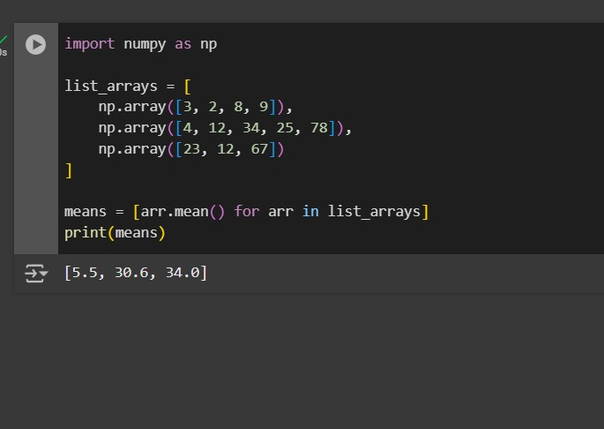

**2. Compute the median of the flattened NumPy array**

**Input: x_odd = np.array([1, 2, 3, 4, 5, 6, 7])**

**OUTPUT :**

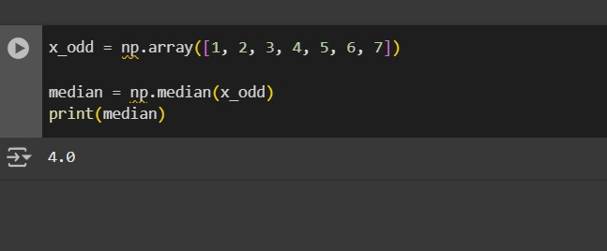

**3.Compute the standard deviation of the NumPy array**

**Input: arr = [20, 2, 7, 1, 34**

**OUTPUT :**

